AI Use Declaration Form
Course: Introduction to Artificial Intelligence
Lab Title: Lab 1 Part A — Uninformed Search Algorithms
Student Name: Victoria Brown Afari
Student ID: 94692028
GitHub Repository Link: https://github.com/victoriabrowwn/ai-course-lab0
Date Submitted: 05/06/26

1. AI Use Summary
Question | Student Response
Did you use any AI tool for this lab? | Yes
Estimated percentage of the work influenced by AI | 25%
Did you attach evidence of AI use where applicable? | No

2. Details of AI Use
Complete the table below for each AI tool used. Add more rows where necessary.
Name of AI Tool Used | Purpose for Using the Tool | Prompt or Instruction Given to the Tool | Part(s) of the Work Influenced by the Tool | How I Verified, Edited, or Improved the AI Output
Chat GPT | For generating code for tasks and fixing errors | Fix the error in this code | Exercises 4-7 | Specialized it to the question given
- | - | Creating arrays using np.ones and array slicing | - | -
- | - | normalizing a random array | - | -
- | - | how to Implement linear regression solution using normal equations and Calculate theta_hat using the normal equation | - | -
- | - |  | - | -

3. Attachment of AI Output Evidence
Where required, attach evidence of AI use. Tick all that apply. Add more rows where necessary.
Evidence Type | Attached? (Yes, No, N/A) | File Name
AI-generated draft
Prompt history | Yes
Screenshot of AI interaction | Yes
Exported AI conversation
AI-generated code snippet
Revised version showing student input

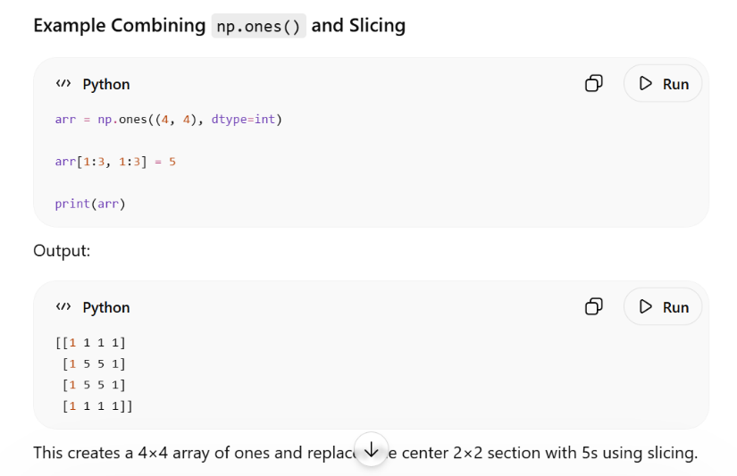
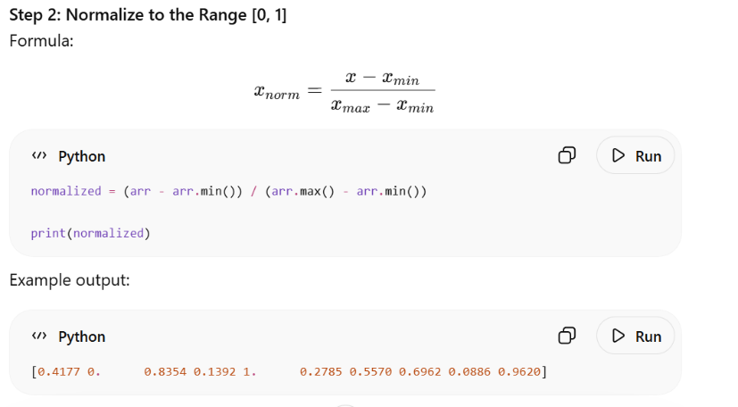
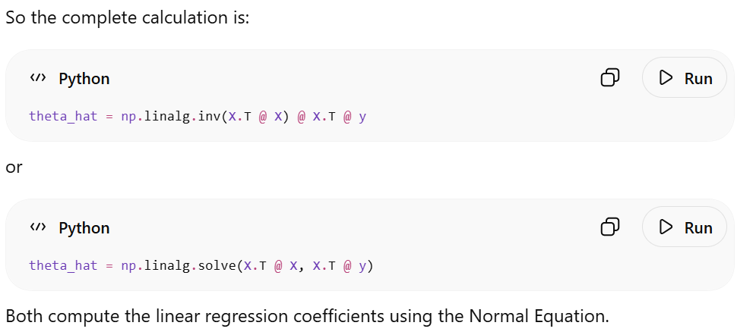

Link to chat history: https://chatgpt.com/share/6a237592-7c14-83ea-bc61-4f122f5c17f1

4. Student Declaration
I declare that:
Declaration Statement | Response (Yes/No)
The submitted work is my own work. | Yes
Any use of AI tools has been clearly declared in this form. | Yes
The prompts, instructions, and AI-generated outputs have been disclosed where applicable. | Yes
I reviewed, tested, edited, and improved any AI-generated content before submission. | Yes
My AI usage does not exceed 25% of the entire work. | No
I understand that undeclared or excessive AI use may be treated as academic misconduct. | Yes

Student Signature: VBA
Date: 06/06/26

